JAVASCRIPT
What is JavaScript
JavaScript was a scripting language (Before 2010).
Before 2010, JavaScript was primarily a client-side scripting language, running inside the browser. It was used to manipulate the Document Object Model (DOM), handle user interactions, and control browser-based components. At that time, JavaScript had no ability to access system resources such as the file system, network ports, or databases, as it was restricted to the browser environment for security reasons.
JavaScript is a programming language (After 2010).
After 2010, with the introduction of Node.js, JavaScript evolved into a server-side programming language. Node.js provides APIs that allow JavaScript to interact with the file system, manage network requests, and perform backend operations. This transformation enabled developers to build complete, scalable web applications using JavaScript on both the client and server sides.
Use or purpose of JavaScript
To make web pages interactive (on demand user should be able to generate elements / UI variables / UI components / UI contents) and dynamic (based on requirement the data of the web page will differs).
Advantages:
- Frameworks and Libraries which are Developed using JavaScript
- Angular, Vue JS, React JS, React Native, Ionic, Ember, Backbone JS, JQuery, Bootstrap, Knockout JS etc etc….
- Typescript Language is based on JavaScript, Typescript also known as superset of JS.
- We can create standalone, mobile, and Game Application using JS.
- We can validate the data provided by the user.
Dis advantages:
- It is impossible to access the local file system directly from client-side JavaScript for security reasons (JavaScript running in a browser is sandboxed, meaning it cannot read, write, or modify files on a user's local system directly.)
- JavaScript is single-threaded and cannot perform true multithreading.
- JavaScript in the browser cannot access data from other websites because of security rules called the Same-Origin Policy. (i.e unable to access web pages of another website from current website).
Why to learn JavaScript?
To make a web page Interactive and dynamic using JavaScript.
To develop client-side Application using JavaScript.
Validate a web page using JavaScript.
What is Program?
Program is a file which contains collection of or set of instruction.
What is Execution?
It is a process of following the instruction written in the program to do some action.
Variables
Variables are the containers in the program where we can store the data.
We use 3 types of variables in JavaScript.
Var the old version(pre-ES6) ,let and const were introduced in ES6(modern javaScript)
Difference between Let , Var and Const.
They behave in 3 different ways in terms of scope, hoisting, and redeclaration.
- Hoisting
- Scope/Memory
- Redeclaration/ Updation.
Rules to follow while making use of variables
1. Variable name should contain only letter, digits, symbols($) and (_)underscore
2. First character must not be the digits
3. Variable Names should be in camelCase
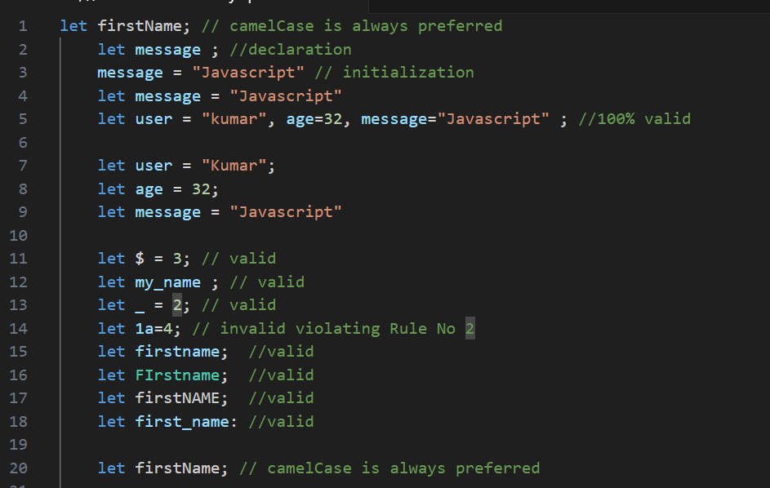

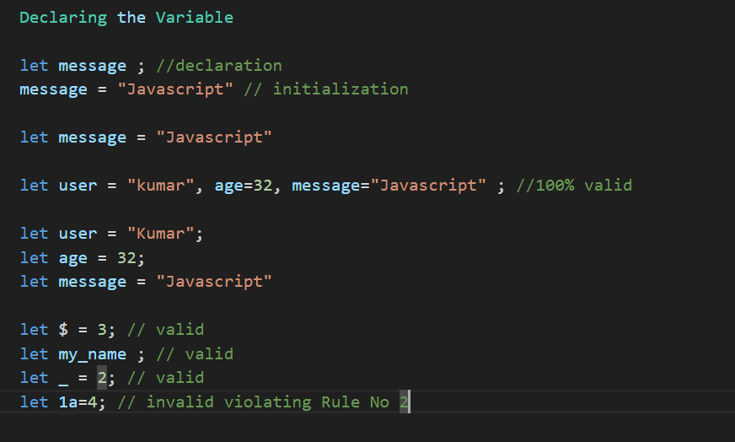

4. Variable Names are Case Sensitive
let apple; // both are not same in javascript
let aPple;

5. Should not use keywords/reserved words
let let=10; // error
https://www.w3schools.com/js/js_reserved.asp

Hoisting
Hoisting means it is a mechanism where it moves the variable/function declaration to the top of its nearest scope but with let and const hoisting will not work .
Scope/Memory
var is a function level scope and will be available throughout the function
let/const are block level scope { } which will be access only in that block.
Redeclaration / Updation
var supports redeclaration and updation.
let supports only updation
const no redeclaration / updation will takes place.
For objects/arrays, the reference is constant — but the contents can be modified.
EXAMPLE:
VAR redeclare and update:
var a = 10;
var a = 15; ---- redeclaration allowed
var a = 98; --- redeclaration allowed again
a = 100; --- updation allowed
console.log(a); // 100-Now “a” holds value as 100.

var a; -- re-declaring again (safe with var)
console.log(a); --- a is declared but not yet assigned, JavaScript initializes it with undefined
a = 10;
console.log(a); --- 10 Now “a” holds value as 10.

LET — redeclare and update
let b = 15;
let b = 20; --- ❌ Error: Identifier 'b' has already been declared(You cannot declare let b again in the same block or scope.)
b = 100; --- ✅ Updating is allowed.
console.log(b); --- 100

CONST — redeclare and update:
const k = 10;
const k = 20; --- ❌ Error: Identifier 'k' has already been declared
k = 25;-- ❌ Error: Assignment to constant variable.

const with Arrays —reassigning array is not possible but we can change value for the index of arr
const arr = [1, 2, 3, 4];

arr = [5, 6, 7]; // ❌ Error: reassignment not allowed
arr[0] = 0; // ✅ Allowed — modifying an element
console.log(arr); // [0, 2, 3, 4]
var in a loop
- var is function-scoped, so it’s accessible anywhere inside the function, even outside the loop.
- If you try to access it outside the function, it throws an error.
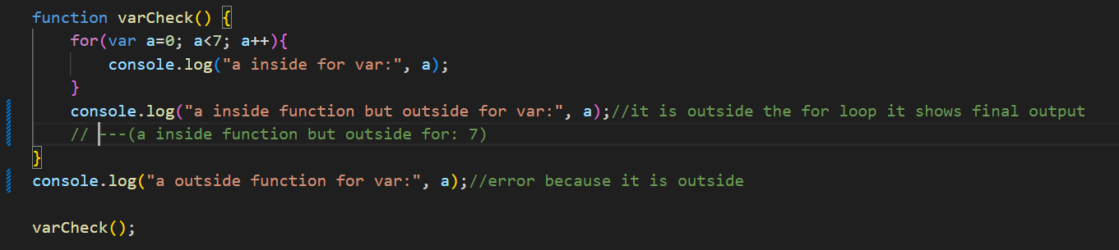
let in a loop
- let is block-scoped, so it exists only inside the for loop block.
- Trying to access it outside the loop or outside the function throws an error.
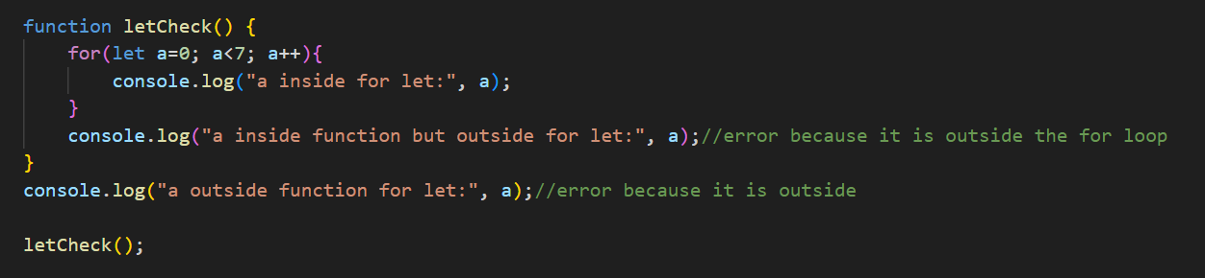
const in a loop
- Like let, const is block-scoped.
- However, you can’t reassign a const value, so typically in loops, you'd use let unless it's a fixed value.
- In your example, you’re using let — but for clarity, here’s how it works if it was const (which would throw an error on the second loop):
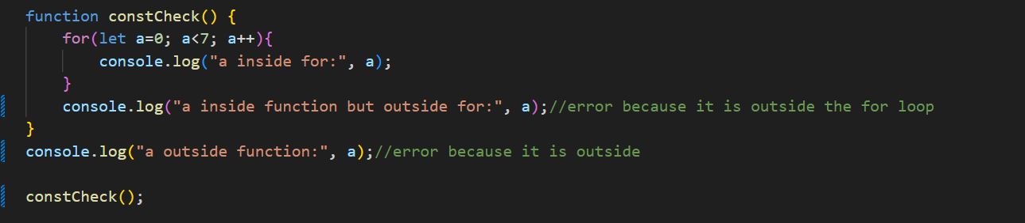
DataTypes
Data type used to store single value are known as Primitive data types
Number, string, Boolean, symbol, undefined, null, bigInt
Data types are used to store multiple values are known as Non-Primitive Data types
let x = "a";
console.log('x', x); // a
let y = x;
console.log('y', y); // a (copy of x's value)

x = "d";
console.log('updated x', x); // d

console.log('Again y', y); // a (still old copy)
Non-Primitive: OBJECT, ARRAY, FUNCTION

let r = {value: "a"};
console.log('r', r); // {value: "a"}

let q = r;
console.log('q', q); // {value: "a"}

r.value = "d";
console.log('updated r', r); // {value: "d"}
console.log('q after r change', q); // {value: "d"}
Now q and r are dependent because they both refer to the same object

Functions
functions are the building blocks, reuse code(Allow not to repeat the code) and organize logic
Function Declaration and Function Expression.
Function Declaration follows Hoisting so calling is possible without declaration.
Function expression calling is not possible without declaring it.
function declaration
sum(5, 5); -- Can be called before declaration due to hoisting
function sum(a, b) {
return a + b;
}
console.log("sum:", sum(5, 5)); -- 10
Function Expression:
A function is assigned to a variable.
let add = function(a, b) {
return a + b;
};
console.log("Addition:", add(5, 10)); -- 15
Calling add() before this line would cause an error because hoisting is not supported.
console.log(add(5, 10)); -- Error: Cannot access 'add' before initialization.
Arrays
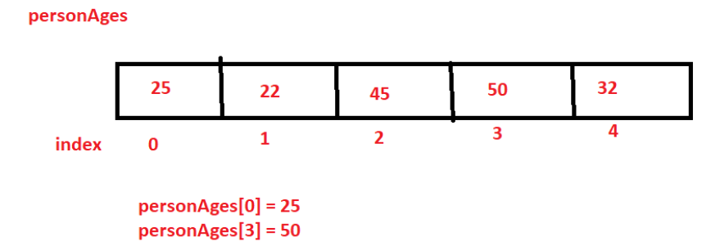
// let array1 = [10, 20, 30];
// console.log(array1);

// //employee

// let employee1 = ['Ajay', 35, 7500.99, true];
// console.log(employee1);

// //length
// let personAges = [25, 22, 45, 50];
// for (let i = 0; i < personAges.length; i++) {
// if (personAges[i] % 2 == 0) {
// console.log(i, " personAges ---- ", personAges[i]);
// }
// }
// //modify
// personAges[1]=23;
// console.log(personAges);

// const personAges = [25,22,45,50,45,20,60];
// personAges[5]=55;

// console.log(personAges);

// personAges = [25,40,32,80];

// let items = [250,500];
// // ADD REMOVE
// items.push(100);
// console.log(items);
// items.pop();
// console.log(items);
// items.unshift(120);
// console.log(items);
// items.shift();
// console.log(items);

// let arrayA = [250,500];
// let arrayB = [150,500];

// arrayA= arrayA.concat(arrayB);
// console.log(arrayA);

// arrayA.sort();
// console.log(arrayA);
// arrayA.reverse();
// console.log(arrayA);

// console.log(arrayA.toString());
// console.log(arrayA);

// let firstArray = [10,20,30,40,50,10,20,30,10,50,90];

// //sub array from firstArray

// console.log(firstArray.slice(3,6)); //
// let firstSubArray = firstArray.slice(3,6);
// console.log(firstArray);

// // indexOf
// console.log("index of -------",firstArray.indexOf(10)); // 0
// console.log("index of -------",firstArray.lastIndexOf(10)); // 8

function show(element){
console.log(element);
}

function doSomething(){
var printArray = [10,20,30,40,50,10,20,30,10,50,90];
// printArray.forEach(show);
printArray.forEach((element) => {
console.log(element);
})
}
//doSomething();

var numbers = [10,20,30,40,50,60];

// add + 2 to all

// numbers.map(function(num){
// num = num+2;
// });
// var result = numbers.map((num) => num+2);
// console.log(result);

// var result1= numbers.reduce((a,b) => a+b);
// console.log(result1);

// var result2 = numbers.filter(num => num>35);
// console.log(result2);

//Adding elements 1,2,3 from 0 index
//= 1 2 3 10 20 30 40 50

numbers.splice(0,0,1,2,3);

console.log(numbers);

// 30 40
numbers.splice(5,2);
console.log(numbers);

let a = 10;
let b = true;
let c = 'Apple';
let array1 = [a,b,c] // array packing
array1[0];
//unpacking
var x , y , z;
[x,y,z]= array1;
console.log(x);
console.log(y);
console.log(z);
console.log(array1);
Objects
An object is a simple data structure used to store and manage data.
Property Format data will be stored in the object.
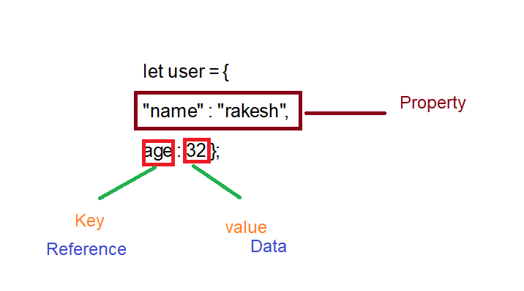
- Keys (also called properties) are unique strings.
- Values can be any data type — numbers, strings, arrays, functions, or even other objects.
LITERAL NOTATION
let user = {
"name" : "rakesh",
age : 32s };

To access the object properties we have (.dot) notation and ([]square) notation.
console.log(user);
console.log(user.name);
console.log(user.age);
// //add property
// user.isAdmin = false;

// user.age = 31;

// console.log(user);

// delete user.age;

// console.log(user);

// let a = 10;
// delete a;
// console.log(a);

// user = {
// "likes code": true
// }

// console.log(user.likes code);

// console.log(user["likes code"]);
const value=10;
let user = {
const : 10,
return : 20
}
console.log(user.const);

let users = [];

let userOne = {
name:"rakesh",
id:123,
age:31
}

users.push(userOne);
users.push(userOne);
users.push(userOne);
users.push(userOne);
users.push(userOne);

console.log(users);

let userDetails = {
name:"krishna",
age:31,
id:123,
hobbies:["singing","shopping","dancing"]
}

console.log(userDetails.hobbies[1]);
Conditional Statements and Loops
Arrow Functions
Arrow Function: (introduced in ES6)
quick and neat way to write functions example:
in FUNCTION EXPRESSION we have to write code to sum of 2 variables.
let sum = function(a, b) {
return a + b;
};
arrow function is a simplied code reduce of lines
Example with return:
let addingNumber = (a,b) => { return a+b };
console.log('addingNumber',addingNumber(2,1))
Even shorter
let addingNumber = (a,b) => a+b;
console.log('addingNumber',addingNumber(2,1))
ANOTHER EXAMPLE:
let double = function (n) {
return n*2;
}
//let doubleNumber = (n) => { return n*2 } inorder more simplyfy.
let doubleNumber = n => n*2
console.log('doubleNumber',doubleNumber(2))

ES6 Basics (like let, const, spread/rest operators, etc.)
Let const already explained above.
//Requirement:1 Need to form new array by removing last 2 values from current
//using SPLICE

const transport =['car','bus','van','jeep','bike','scooter']

const splice =transport.splice(2,2);//Removal --- splice(from which index, how many delete)

console.log('splice',splice);
//output ['van','jeep']

//Requirement:1 Need to form new array by removing 2 values from current array
//using SLICE
const vehicles =['car','bus','van','jeep','bike','scooter']

const slice =vehicles.slice(2,3);//Removal --- splice(from which index, how many elements)

console.log('slice',slice);
//output ['car','bus']

//using CONCATE

const number = [1,2,3,4]

//joining an array
const join = transport.concat(vehicles,number);// in concat(we can define n number of arrays separated with comma

console.log('JOIN', join);

//FIND INDEX
const vehi =[
{id:1,title:"car"},
{id:2,title:"bus"},
{id:3,title:"van"},
{id:4,title:"jeep"},
{id:5,title:"bike"},
{id:6,title:"scooter"}
]

const findIndex = vehi.findIndex((val)=>{
//return val.id == 2;
return val.title == "van";
})

console.log('findIndex',findIndex);
//OUTPUT: index value

//FIND
const vehic =[
{id:1,title:"car"},
{id:2,title:"bus"},
{id:3,title:"van"},
{id:4,title:"jeep"},
{id:5,title:"bike"},
{id:6,title:"scooter"}
]

const find = vehi.find((val)=>{
//return val.id == 2;
return val.title == "van";
})

console.log('find',find)

//OUTPUT: object will return

Why we have to use Promises ?
If there is any heavy operation in JavaScript—like fetching data, performing complex logic, or accessing files—that takes more time to complete, it can delay the normal execution flow since JavaScript runs in a single-threaded environment.
To avoid blocking the main thread, we handle such tasks asynchronously. However, if we want to maintain a controlled, step-by-step (synchronous-like) flow, we use Promises or async/await.
What is Promises ?
A Promise is a (special object or data structure) in JavaScript used to handle asynchronous operations.
Promises allow us to run heavy code separately without interrupting the main execution, and they also let us chain or wait for tasks in a readable and manageable way
A Promise represents a value that may be available now, in the future, or never.
A Promise has three possible states:
- Pending — The operation is still in progress.
- Fulfilled/resolved (Success) — The operation completed successfully.
- Rejected (Failure) — The operation failed.
How to Create a Promise Object ?
To create a Promise, we must use
- new Operator
- Promise() (pre-defined constructor)
const prom = new promise((resolve,reject)=>{})

EXAMPLE:
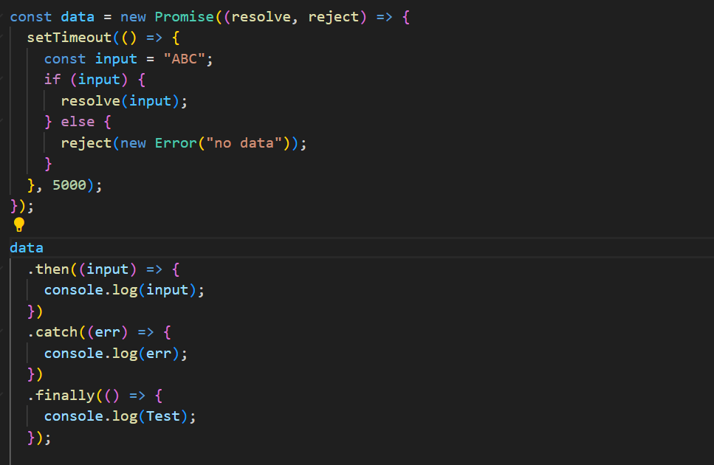
//using API call
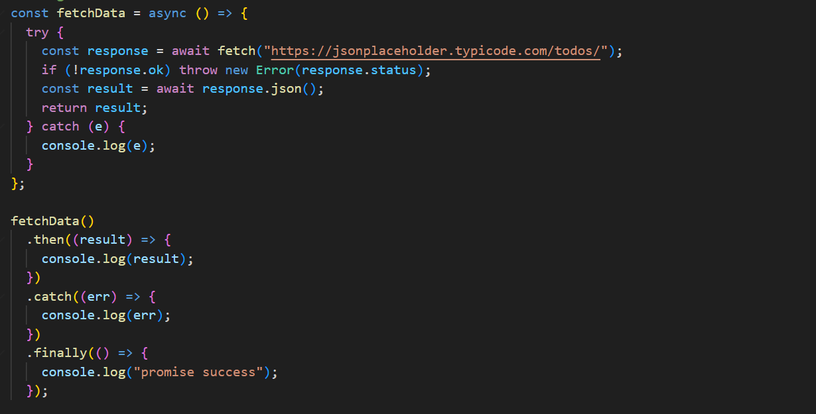

Basic DOM Manipulation (optional)

